**Assignment Topic : Colour Scheming**

**Name : Mehnaz khadam**

**Class Name : Web design and development**

**Batch : j13**

**Colour scheming :**

First of all the colours are beautifull and look attractive when it is used in same where. Like in food in fabric and in different brands. Some colours are natural like green .

Green and sky colour found everywhere like in plant fruits and on the sky so these are called the natural colours.

***RED COLOUR:***

The meaning of red colour is passion warmth love. This colour attracts the most attention and is associated with strong emotions such ass love and anger. Red is the colour used universally to signify danger courage strength and power . Red is stimulating vibrant and exciting.

In Chines culture red represents luck and prosperity . Use red when you wnt to get pulses racing and to inspire action. However use carefully as red can evoke feelings of aggression and cause visual strain.

Red colour are used in many brands but I wil name of one brand that is coca cola.

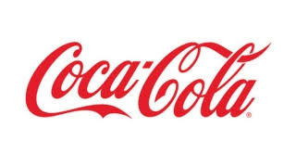 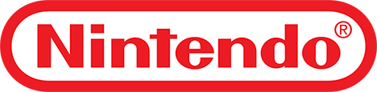 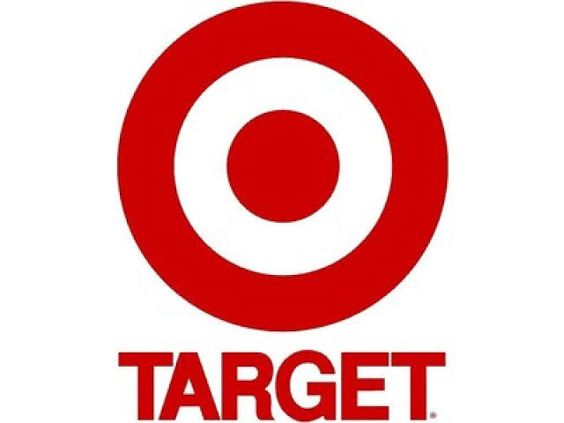

***Black colour :***

Black is a color that is often used to portray something evil, depressing, scary and even death in the Western civilization. The black color meaning is often negatively charged, as in “blackmail”, “blacklist” and “black hole” etc. Black is also a very powerful color that symbolizes class, elegance and wealth. Stylish clothing is often designed in black, everything from suits, The color black is a color that fits in almost any design. It adds contrast and makes the other colors stand out more۔The black color is the absorption of all colors and the absence of all light. Black hides things, The color black can also be used to absorb negative energy.

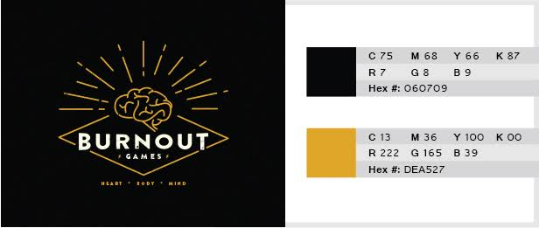 Contest Entry #14 for I need to design a logo for a property development company. The company is called Delphi Property Group.
I like to have a luxurious, black and gold colour. Job will include letterhead, business card and all other stationary designs

 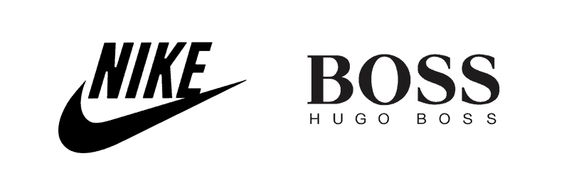

***Orange :***

Meaning of orange colour is cheerfulness , low cost, affordability, enthusiasm, stimulation, creativity, aggression.

Blending the warmth of red and the optimism of yellow, orange communicates activity and energy. And of course it’s hard not to go past orange as the color of, well, oranges, and all their vitamin c byproducts, which immediately makes orange feel fresh and healthy. Orange is not for everyone (it was certainly the color of the decade in the 1970s) and can therefore tap into associations of youthfulness, creativity and adventure.

Orange expresses the creativity and energy of the agency.

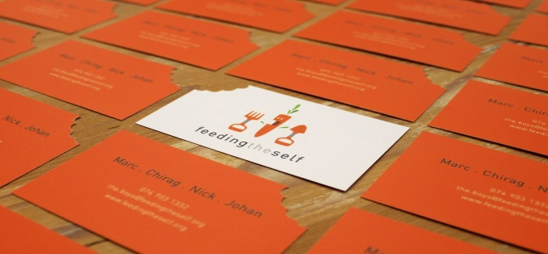 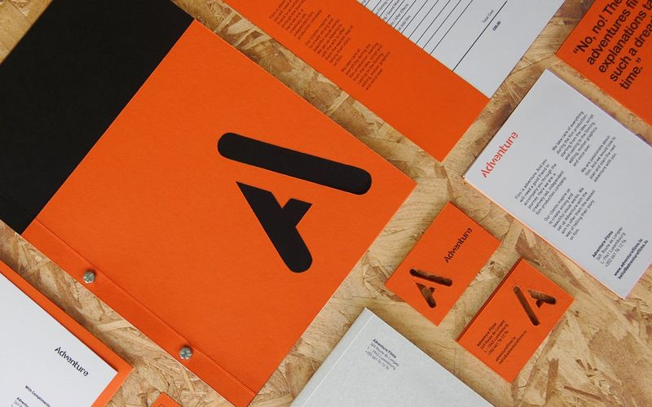

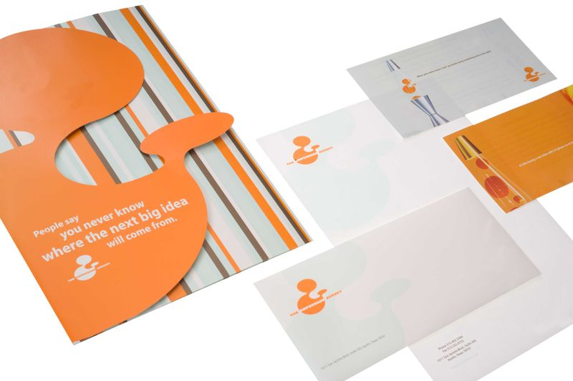

|  |
| --- |
|  |

***Yellow :***

Meaning of yellow colour is attention , grabbing, comfort,liveliness hunger, energy, conflict, overwhelm.

Being the color of sunshine, yellow puts a smile on the dial. It is the most visible color from a distance (which is why it’s used for street signs) and communicates cheerfulness, friendliness, joy and energy. yellow is also a cautionary color used in life vests, police cordoning tape and hazardous areas. Some shades of yellow can look cheap—although this may suit your brand image. So yellow is a great example of when to research consumer reaction to color appropriateness and make sure it is the right color for your product. Make sure to use good design if you want to avoid any feeling of cheapness.

|  |
| --- |
|  |

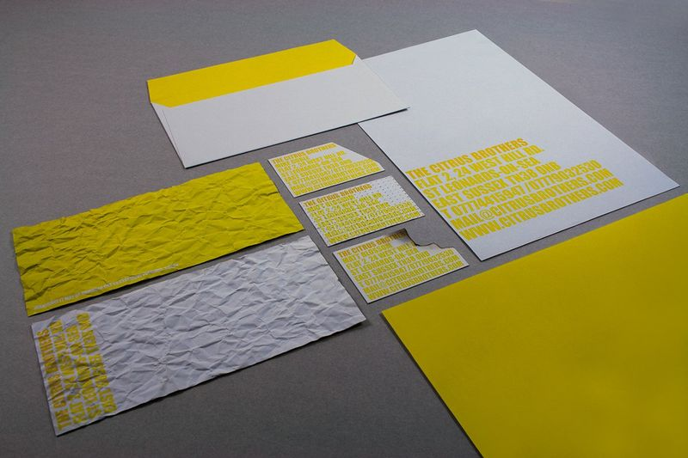 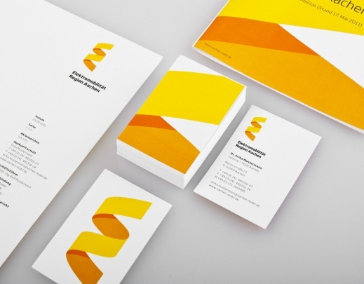 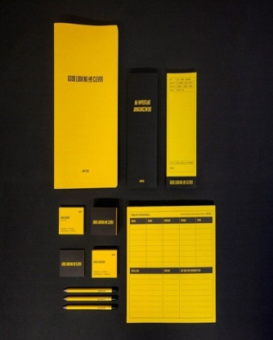

***Green :***

Green colour mean durability, environmental, luxurious,freshness,safety,calm

Green has two very common meanings that are quite paradoxical; one being nature and the environment, and the other being finance and wealth. When it comes to nature, green represents plant life and growth and is consequently used to convey being ‘green’ in the environmental, sustainable, organic, natural sense of the word. And of course green is, as the saying goes, ‘the color of money’ (US money, that is) and therefore associated with wealth and stability.



  
  
  

